Queensland State Schools Resourcing Framework Guide

School funding appropriations
School staffing allocations
System-provided resources

Updated July 2022

Contents
Introduction 3
School income sources 4
School resourcing framework 5
School funding appropriations 6
Core appropriations 7
Targeted appropriations 7
Appropriations available by application 7
School staffing allocations 8
Core staffing allocations 8
Targeted staffing allocations 9
Staffing and resources available by application 9
System-provided resources 10
Infrastructure 10
Information and communication technologies (ICT) 11
Human Resources 12
Finance and Procurement 12
Central and regional office support 13
Further information 14
Copyright
© The State of Queensland (Department of Education) 2022.
Copyright protects this material. Except as permitted by the Copyright Act 1968 (Cth), reproduction by any means (photocopying, electronic, mechanical, recording or otherwise), making available online, electronic transmission or other publication of this material is prohibited without the prior written consent of the Department of Education.
Contact
Queensland State Schooling Resourcing, Finance Branch
Phone: 07 3055 2840
Email: Stateschoolresourcing@qed.qld.gov.au
TRIM: 22/485682 (accessible version)

Introduction
Queensland state schools are resourced to deliver high quality education services, improve student learning outcomes and manage school operations. School resourcing including staffing, funding, infrastructure and information technologies is provided through allocated methodological formulae and specific determinations made at central and regional levels. The overarching resourcing arrangements are focused on addressing student needs across the state-wide footprint of Queensland state schools. All schools receive core resources and these may be supplemented by targeted resources to support schools to address specific needs. These may include:
- the needs of rural, remote and small schools
- closing the historical gap in educational achievement between Indigenous and non-Indigenous students
- addressing the link between low socio-economic status (SES) and poorer educational outcomes
- meeting the education adjustment and support needs of students with disability.
This guide provides a high-level summary to help school leaders better understand their school resource allocations. For information on individual school-level allocations, Queensland state schools have access to a secure on-line School Budget Solution. Further information is available to principals and other staff through the department’s intranet (OnePortal) or regional offices.

School income sources
Around 95% of Queensland state school revenue comes from a combination of Queensland and Australian Government funding, with the remainder from school-derived income such as fundraising by Parents and Citizens’ (P&C) associations and donations. Schools are funded to provide students with instruction, facilities and administration. Government funding is allocated each year to schools predominately as school funding appropriations and staffing allocations, with schools developing and implementing annual plans and budgets for the use of these resources. Cash from appropriations and school-derived income is managed through school bank accounts to meet operating expenditure and minor capital works.
Parents are responsible for providing textbooks, consumables, and equipment (such as musical instruments, or personal ICT devices when opting into 1-to-1 programs) to enhance student learning. Schools may, if they choose (in consultation with school P&C associations), offer a Student Resource Scheme as a convenient and cost effective way of sourcing the resources students require. Student Resource Schemes are run on a cost-recovery basis, and participation is optional for parents. Schools may also operate a voluntary contributions scheme to improve facilities and amenities, including classroom consumables or student ICT devices.
Figure 1: Queensland state schools income sources and resource allocations
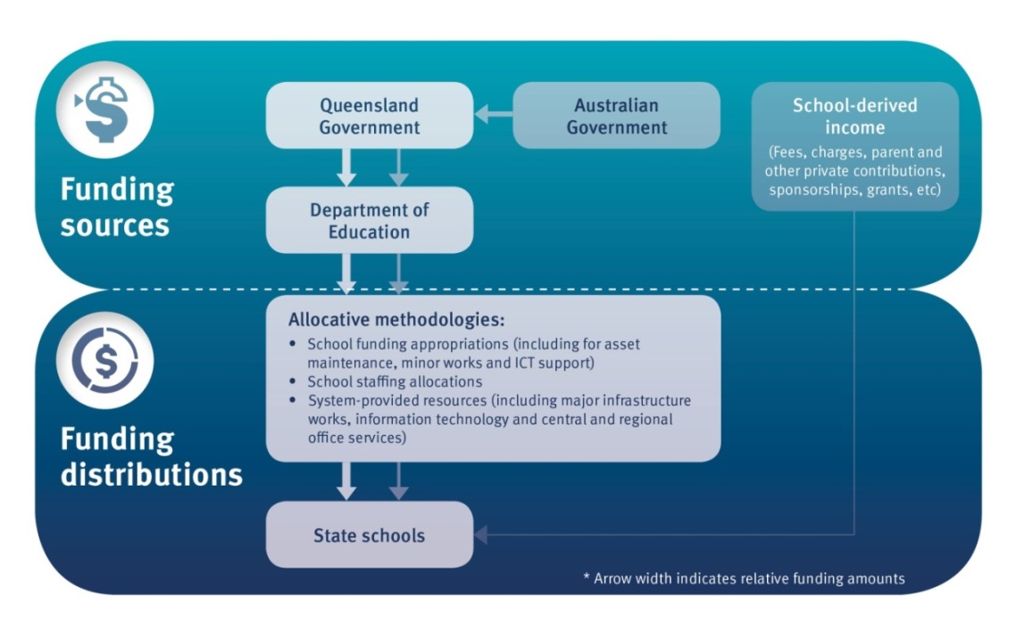

School resourcing framework
Queensland state schools are resourced through a combination of school funding appropriations, staffing allocations and system-provided resources. Queensland state schools have significant autonomy in the management of their resources, with core funding appropriations and staffing allocations managed flexibly within legislative and industrial requirements. The framework’s vision is for predictable, flexible, needs-based and outcome-focused school resourcing. Central office, regions and schools are all required to achieve value for money by identifying and prioritising objectives, monitoring budgets and assessing benefits.
Figure 2: Queensland’s state schools resourcing framework
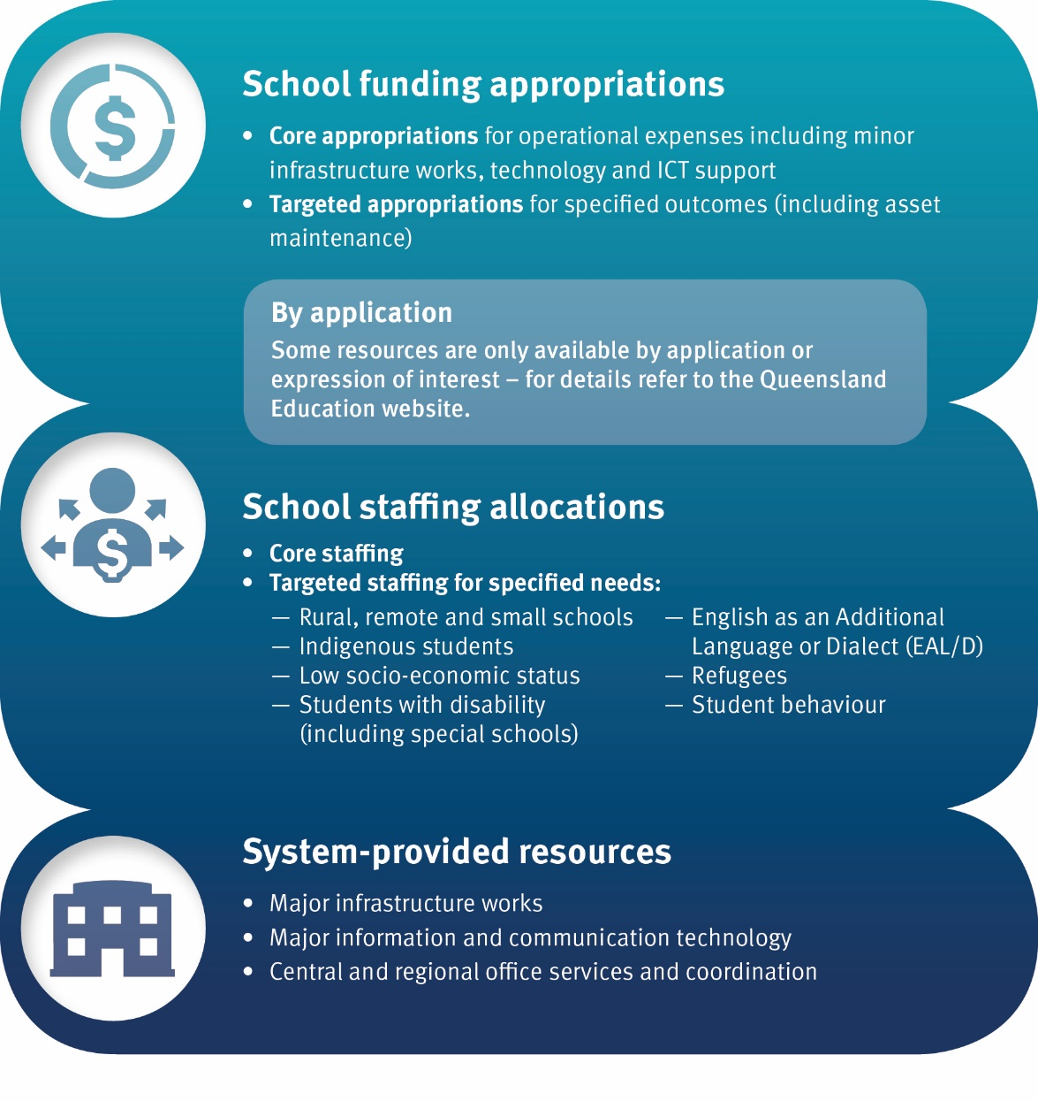

School funding appropriations
Funding is appropriated to Queensland state schools from state and federal sources to meet recurrent operating costs and student needs, and to support implementation of specific programs and initiatives. This includes information technology support, asset maintenance and minor infrastructure and capital works. The department publishes online a list of all school appropriations.
Funding is paid to schools (or host schools) regularly throughout the year depending upon the specific terms of the appropriation. Schools receive main operating payments once per term, and receive other program payments in accordance with program specifications (e.g. monthly or quarterly), totalling a possible 16 appropriation payments per year. The online profiles provide guidance on payment timing for each appropriation.
Appropriations are categorised as:
- core funding – that does not require financial acquittals and
- targeted funding which must be spent for the specified purpose and accounted for separately.
Some core and targeted funding requires an application by the school. Both core and targeted appropriations are used to address student disadvantage.
The formulae underpinning school appropriations depend on identification of specific school and student needs. Different rates apply depending on the characteristics of each school. Also different school types and groups of schools are eligible for different appropriations.
Some school appropriation formulae may include one or more base per student and/or base per school amounts. The annual base per student amount may be determined by the budgeted annual allocation for all schools in a particular year. For example, there is an annual state-wide budget allocated to support Indigenous students to be enrolled, engaged and achieving in school, and progressing at the same rate as non-Indigenous students. Funding is provided to schools from this budget on a needs-basis taking into consideration a number of factors including a school’s Indigenous student enrolment. In some cases the base per student amount is combined with other factors in the funding calculation (e.g. Index of Community Socio-Educational Advantage (ICSEA) weighted enrolments, locality index). Other components include: funding equivalent to notional staffing entitlements; funding based on teacher relief costs; funding based on specific curriculum offerings or other eligibility criteria such as geographic location or size of school grounds; shared funding allocated to clusters of schools; or funding allocated on a regional basis.

Core appropriations
Core appropriations are provided to schools to meet operating expenses and student needs. There is considerable flexibility around school use of these funds. Core appropriations are categorised into general operating appropriations to meet general recurrent operating costs and other appropriations for specific programs or initiatives.
The main school appropriation assists schools to meet recurrent operating costs. All Queensland state schools, including Schools of Distance Education, are eligible for general operating appropriation funding. Some 100 smaller appropriation categories exist to support specific school or student needs and programs. The full set of core appropriations equals the overall allocated school funding budget that is managed flexibly by the school.

Targeted appropriations
Targeted appropriations are provided to schools to meet specified outcomes such as enhancing educational outcomes or providing experiences for groups of students identified with specific needs. Targeted appropriations must be used for their specified purpose and may involve acquittal or accountability mechanisms including reporting publicly or to School Councils and/or P&C associations.

Appropriations available by application
Most funding appropriations are calculated and paid automatically based on the school's eligibility as determined by each program’s policy. However, some require specific application or expression of interest to receive funding. For further information, refer to the online school appropriation profiles.

School staffing allocations
The majority of staffing resources that flows to Queensland state schools is not paid as cash to the school but rather is delivered through notionally allocated full-time equivalent (FTE) staffing positions. The allocation of teachers and other staff is determined by formulae that take into account schools’ enrolment profiles and other characteristics. Principals are able to flexibly use staffing allocations to meet the needs of the school, within the context of legislative, industrial and departmental policy frameworks.
School staffing allocations are categorised as:
- core staffing allocations or
- targeted staffing allocations.

Core staffing allocations
The core notional allocation of staffing resources for all schools is intended to support diverse levels of student need. School allocations for both teaching and non-teaching staff are determined by a range of approved methodologies. School staffing allocations are generally determined on the basis of enrolments as at the eighth day of the school year (Day 8), confirming the number of classroom teachers, promotional positions (heads of department and deputy principals), teacher aides and administrative support allocations.
Principals have flexibility to determine the most appropriate mix of their allocated staffing resources, including being able to consume resources at different times during the year, as different types or classification of positions and/or convert allocations to cash. This flexibility exists within a well-defined industrial relations framework that involves local-level consultation. Schools may convert core staffing allocations to cash using processes managed by the department’s Human Resources Branch together with information provided by regionally-based human resources teams to ensure arrangements comply with relevant legislative, industrial and departmental policy requirements.
Each year, it is the responsibility of principals to manage the school staffing establishment in accordance with teaching and support staff allocations and relevant industrial instruments. The core establishment can be supplemented through school-funded positions. A multi-year forecaster is provided to schools to assist with workforce planning.

Targeted staffing allocations
To help address the diverse learning needs of students, targeted staffing allocations are provided directly to schools or to regions. For the commencement of the school year, schools are provided with indicative targeted resources based on forecast enrolment numbers provided the prior year. Once enrolment numbers are confirmed on Day 8, targeted resourcing allocations are adjusted accordingly. The formula-driven resource allocation models used to calculate targeted staffing entitlements are the Students with Disability allocative model and Whole School Support – Student Learning Resources (WSS-SLR) model.
Staffing allocations to address student needs include weightings based on factors such as Socio-Economic Status (SES), Index of Community Socio-Educational Advantage (ICSEA), length of time in Australia for new arrivals/refugees, and the level of educational adjustment required for students with disability.
Specialist staffing provided as part of the targeted resourcing is allocated to schools based on assessment of data and emerging local need. This approach is advantageous as it influences the development of schooling models such as ‘clustering’ and ‘hosting’ to share resources across schools. Specialist staffing resources are allocated for various categories of students identified as having additional educational support needs (for example, students with disability and students for whom English is an additional language or dialect (EAL/D)).

Staffing and resources available by application
Each region is allocated a funding pool as part of the allocative models to assist in responding to unique, emerging and complex situations in schools. Schools may apply to the regional office to access these funds if additional support is needed to manage local or complex issues, particularly those that arise during a school year. For example, this funding may be used for improved school capacity or additional focused teaching support.

System-provided resources
System-provided resources are provided ‘in kind’ by central and regional offices for all state schools. A broad array of system-provided support services and resources are available to schools to support their operations. These include:
- infrastructure
- information and communication technologies
- human resources
- financial, procurement and audit services
- education and delivery support services and coordination.

Infrastructure
Major infrastructure funding is administered and coordinated centrally, whereas asset maintenance and minor infrastructure works are funded via school appropriations. Major infrastructure investment is categorised as either:
- growth — infrastructure investment to meet demographic demand growth requirements (new schools and additional capacity for existing schools)
- renewal — replacement or enhancement of existing school facilities
- specific purpose — nominated investments with defined funding sourced external to base departmental infrastructure funding
- maintain and sustain — works to enable the continued operation of infrastructure in accordance with existing functionality requirements.
Through investments to maintain and sustain school assets, state schools receive separate core and targeted appropriations for minor works and maintenance funding. Principals and their communities have the choice to use services provided through the Department of Housing and Public Works (DHPW) Building and Asset Services (BAS) division to deliver maintenance services or source local contractors to deliver planned, emergency and routine breakdown maintenance via a direct to market (D2M) delivery option. Schools are able to choose their maintenance provider at the commencement of each financial year. Schools choosing D2M are allocated funds directly to their bank account. Schools using the BAS delivery model have a notional allocation that is supported by automated billing arrangements that seek to reduce the administrative burden on schools.
Planned maintenance priorities/tasks are selected by schools from information in the school’s Asset Life Cycle Assessment (ALCA), conducted by an external contractor. These tasks are funded from the school allocation. Schools routinely identify minor maintenance items such as dripping taps and use their maintenance allocation and/or other available resourcing to rectify these issues. Additional funding for emergency maintenance is pooled and held regionally, and there is a centrally-held allocation to fund health and safety issues. Disaster and emergency management (fires, floods, cyclones) expenditure is managed centrally and is supported through the Queensland Government Insurance fund (QGIF).
Schools have discretion to use appropriated funding for upgrade works, maintenance or small capital projects.
Where a school has significant maintenance issues that cannot be addressed from within its available resourcing, these can be escalated to the regional infrastructure team for consideration under special maintenance funding. For further information, schools should contact their Infrastructure Advisor or visit the School Maintenance webpage on OnePortal.

Information and communication technologies (ICT)
All state schools benefit from a wide range of centrally-coordinated ICT initiatives.
The Information and Technologies Branch business model provides services via a three-tiered delivery framework, which gives schools choice in how they access digital services:
- Enterprise services — centrally funded IT services are delivered to all schools, with end-to-end service guarantees and defined standards Examples include departmental applications (OneSchool; Blackboard); network infrastructure; ICT security; software licencing; and Computers for Teachers program
- On-demand services — additional investment in services to meet increased demand and service innovation. Examples include increase in internet bandwidth and additional wireless infrastructure
- Third party managed services — optional brokered IT services (external to the department) to meet school needs which are compatible with existing enterprise services. Examples include electronic attendance management systems and online library management systems.
Schools receive allocations for ICT within their appropriations, which may be supplemented by other available funding, for the management of local ICT assets. Examples include school servers and computers. Schools also receive additional funding to support ICT assets.
Schools are required to manage ICT assets using a lifecycle approach through five stages of plan, purchase, implement, utilise and enhance/retire.
Principals and other staff can refer to OnePortal for detailed information on services provided by Information & Technologies Branch.

Human Resources
A range of human resources support and delivery functions are provided by the department through centrally or regionally based service teams. Recruitment, payroll, staffing, workforce management, workplace health and safety, industrial relations and rehabilitation advisory and support services are provided through specialist teams. This approach provides highly cost-efficient and specialised services that reduce the administrative burden on schools.
The human resources function of the department negotiates employment conditions and agreements, assists with investigations and disputes, undertakes investigations and provides advisory services and support.

Finance and Procurement
The department provides a standardised school financial management system and processes to support schools in the management of their financial resources. These processes are supported through centrally and regionally based teams providing expert advice and direction in the areas of finance and procurement. Schools benefit from being able to enhance purchasing power through the use of standing offer arrangements with suppliers, and have access to regional financial staff to support planning, management, compliance and accountability.

Central and regional office support
To help principals meet their financial and resource management responsibilities, the department provides a range of systems, tools, policies, procedures and training. Centrally and regionally administered services and programs include:
- governance and reporting frameworks and services
- curriculum support and coordination
- school sport
- risk management
- policy, planning and performance advisory services
- school leadership development programs
- curriculum materials and services
- research and data analysis, including the annual School Opinion Survey and the Next Step survey of Year 12 completers
- P&C and School Council support
- legislative and legal support services
- communications, media and marketing support services
- state-wide coordination of specialist services such as therapists and counsellors, including disability support services.
For further information, principals and other staff can refer to their regional advisory services or information on OnePortal.

Further information
Click on the links below for further details. Additional information is available to principals and other staff through the department’s intranet (OnePortal).
Table 1: Key website links
Topic | Web address
School funding appropriations | https://education.qld.gov.au/about-us/budgets-funding-grants/grants/state-schools
Regional office contacts | https://education.qld.gov.au/contact-us/state-schools-regional-contacts

The word Indigenous in this document refers to Aboriginal and Torres Strait Islander people of Australia.

