Developing a human rights culture in the Department of Education
  - June 2020

Contents
Introduction 3
Education and staff development 6
Community consultation and engagement about human rights 9
Awareness raising and support for related entities 11
Reviews and development of legislation or subordinate legislation 13
Review of policies and procedures 15
Implementation of internal complaint management for human rights complaints 18
Future plans 20
Pandemic response and recovery impacts on implementation activities 21

Introduction
The Department of Education (the department) plays an important role in shaping Queensland’s future through quality early childhood education and care, high performing state schools, and harmonious and inclusive workplaces.
As part of the department, Queensland’s Office of Industrial Relations promotes a culture of health and safety, productive and inclusive workplaces, economic prosperity and fairness in Queensland. It does this in partnership with the community, industry and worker representatives and through fair and balanced industrial relations and workers’ compensation frameworks.
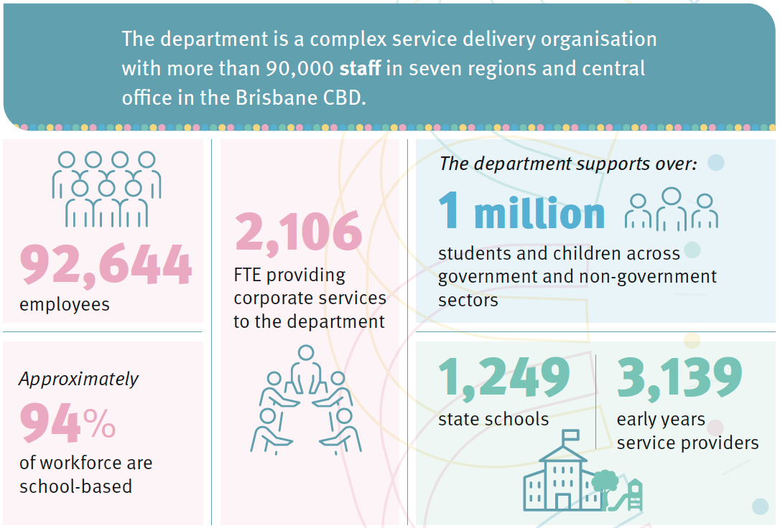
The Human Rights Act 2019 (the Act) commenced in its entirety on 1 January 2020. The Act places the human rights of individuals at the forefront of government and public sector decision making and service delivery, ensuring that all Queenslanders, especially the most vulnerable, have their human rights respected, protected and promoted.
In line with our obligations as a public entity under the Act, over the period 1 July 2019 to 30 June 2020, the department has taken important steps toward meeting the objects of the Act. Non-state schools and early education and care centres are not considered public entities under the Act. During the first phase of implementation, a range of activities have been undertaken to build a culture that respects, protects and promotes human rights.
Reviews of policies, procedures and legislation have highlighted the strong foundation of human rights protections that already existed in the department and identified areas for improvement.

The department’s Strategic Plan 2020-24 highlights our commitment to creating a stronger, fairer Queensland by respecting, protecting and promoting human rights in everything we do. Our departmental frameworks, strategies, operational plans and activities reinforce this commitment.
Existing strategies and frameworks that support the department’s human rights commitment.
Every student succeeding - State Schools Improvement Strategy 2020-24 which encompasses the Every Aboriginal and Torres Strait Islander student succeeding and Every student with disability succeeding plans designed to protect and promote the human rights of vulnerable groups;
Aware.Protective.Safe Strategy which reinforces our commitment to the safety and wellbeing of children and young people and identifies how we are building on our existing child safe environment by implementing the national principles for child safe organisations; and
We All Belong – Workforce Diversity and Inclusion Framework which includes focused strategies for multicultural communities; all abilities; LGBTIQ+; Aboriginal and Torres Strait Islander peoples; and, gender parity.

The department’s future focus for embedding and supporting a human rights culture (aligned to the Queensland Human Rights Strategy) is to:
Our focus
Respect:
Build a culture in the Department of Education that respects and promotes human rights
Protect:
Protect and promote human rights through our everyday actions and services, decisions and systems
Promote:
Promote a dialogue about the nature, meaning and scope of human rights through education, resources, reporting and in our everyday actions
The department’s approach to embedding and supporting a human rights culture is to:
Our approach
Define
Define how our systems and culture currently protect and promote human rights
Strengthen
Strengthen the department’s approach to human rights by lifting capability, awareness and accountability
Embed
Embed systems, structures and education that supports everybody to act and make decisions that are compatible with human rights
Sustain
Sustain a culture that respects, protects, promotes human rights through review and continuous improvement

Indicator 1

Education and staff development
- What education and training on the Human Rights Act has been provided?
- Approximately what percentage of staff have received training? Which work groups or areas of the agency have received training?
- What was the mode of delivery of the training? For example, online, face-to-face, both online and face-to-face, or other?
- Has human rights been included in induction training, and does ongoing professional development/training for staff include human rights? If so, what is the mode of the delivery of the training?

Agency context
The department’s initial focus involved defining how existing department systems protect human rights, raising awareness and building engagement to support a more detailed roll out of capability development and practical resources for all staff. The next stage of implementation requires strengthening and embedding a human rights culture in the department through the development of sustainable and accessible delivery methods for future capability development, particularly for school leaders and school staff; and for field staff.

What we have done
A whole-of-agency communications plan was developed prior to commencement of the legislation to raise awareness about the Act. Agency-wide electronic communication was delivered during 2019-20 through various departmental engagement channels – including direct communication from the Director-General, newsletters, screensavers and intranet communications.
In 2019 and early 2020, the department developed and delivered an education and training package for staff. Three-hour face-to-face workshops were conducted, providing an introduction to the Act and working through examples about rights identification and compatible decision-making. This included partnering with the Department of Justice and Attorney-General (DJAG) and the Queensland Human Rights Commission (QHRC) to deliver face-to-face training sessions to central office staff, focused on building staff capability to review policies, procedures and legislation and assess their compatibility with the Act. Training for regional office staff included a focus on complaints management, human resource decisions and school-based scenarios to build capability in customer complaints teams and with key school support staff.

Initial education and training has focused on awareness raising and introduction to the Act.
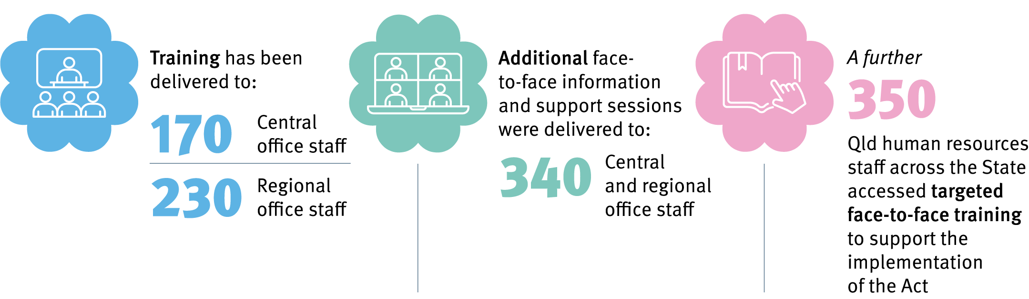
Further face-to-face training for school principals was scheduled to commence in 2020, but did not proceed due to the COVID-19 pandemic. During the current pandemic recovery phase, and in line with the department’s future focus, the department will concentrate on development of sustainable training and development programs to support school leaders and staff through readily accessible and practical programs and tools.
Online training opportunities have been developed to support ongoing awareness and understanding of the Act across the department. The department will build on these opportunities in 2020.
Since January 2020, the department’s Mandatory All-Staff Training program for new employees and the annual Refresher Program for existing employees has included human rights information.
Nearly 67,000 staff completed this training between January to June 2020; 92.7% of these were school-based staff.
Further training content, including an animated video, was developed for the online Management Foundations program, suitable for aspiring, new and current leaders, and released in August 2020.

Future plans
Developing a department-wide and sustainable approach to training for all staff and building the capability of school-based leaders and all people managers is a key priority. By adapting to and learning from the disruption of COVID-19, the department will look to leverage existing departmental systems and platforms, technology and new ways of working to strengthen knowledge about fulfilling obligations under the Act and ensure all staff have access to the tools and resources they need to consider human rights in their everyday actions and decisions.
From July 2020, strategic oversight of human rights implementation and our progress towards embedding a culture that respects, protects and promotes human rights will be supported by an Implementation Working Group with existing oversight of the department’s response to the Royal Commission into Institutional Responses to Child Sexual Abuse (RCIRCSA). The working group has high-level representation from across the department and reports to the Executive Management Board.

Indicator 2

Community consultation and engagement about human rights
- Have you conducted any community consultation and engagement, such as with stakeholders, clients, or consumers about human rights?
- What information have you provided to the community about human rights?
- Have you consulted relevant sectors of the community about proposed changes to, or development of, legislation, regulations, policies, procedures, services etc. which may impact human rights?
- Please provide details, including how the community consultation and engagement impacted on any decision-making/policy formulation, or other.

Agency context
The department has a number of existing avenues for consultation and engagement, including public-facing web pages and social media accounts. The department’s legislation and policy development and review processes include consultation with stakeholder groups, including school communities and Parents and Citizens’ Associations. A Parent and Community Engagement Framework and the Aboriginal and Torres Strait Islander Engagement Framework (under development) support each school’s targeted consultation with communities and offer the opportunity to explore issues related to human rights. Further community consultation on school-based issues often occurs through schools via Parents and Citizens Associations and/or School Councils. Community engagement for OIR is also through safety campaigns with industry and other key stakeholders.

What we have done
Supporting our commitment to human rights, and in particular, rights related to children, education and cultural rights, the department provides a number of initiatives and opportunities for feedback. These include:
- Seeking feedback from students, parents/caregivers, staff and principals through the 2020 School Pulse Survey. Questions asked include perceptions of fairness, safety and inclusivity, and experiences from Term 2 learning arrangements during the pandemic. Feedback from the survey informs departmental strategy, policy and continuous improvement.
- Progressing a ‘Measuring Engagement and Wellbeing’ project for students in 2020. The proposed survey aims to provide insights about the wellbeing of students in state schools, and help to assess areas of need.
- Implementing the Australian Curriculum in Prep to Year 10 in Queensland schools. The curriculum, in each learning area and through the general capabilities, provides opportunities for students to learn about human rights and the Act.

- Making the department’s Respectful Relationships Education Program for Prep to Year 12, available to all Queensland schools, provides opportunities for social and emotional learning in human rights, social awareness, relationships, ethics and values.
The department has updated its website to include information to the wider community about human rights related customer complaints and how they are managed. Departmental social media platforms have also been used to share information publicly about the commencement of the Act; to direct the public to information and resources; and to promote human rights during key public awareness events such as ‘Law Week’ and ‘International Human Rights Day’.

Future plans
Development of a future-focused department Human Rights Framework, long-term implementation plan and a new Communications and Engagement Plan will support ongoing stakeholder and staff engagement and maintain momentum in our approach to building a human rights culture that includes our key partners, stakeholders and members of the public.

Indicator 3

Awareness raising and support for related entities
- Have you raised awareness of human rights with contractors/providers/functional entities
engaged by your agency? If so, provide details.
- What support in ensuring compatibility with the Act, have you provided to providers
engaged by your agency? If any, provide details.

Agency context
The department has worked with our related public entities to help them understand their obligations under the Act and direct them to resources, tools and training.
The department participated in the whole-of-Government Human Rights Inter-Departmental Committee (HRIDC) that considered the impacts of the Act upon agencies, as well as the meaning of ‘public entity’ under the Act. Through the work of the HRIDC, a shared understanding of the scope and impact of the Act was agreed to, which informed the work of the department.
The department has identified the following statutory bodies as public entities under the Act: the Queensland College of Teachers, Queensland Curriculum and Assessment Authority, Non-State Schools Accreditation Board, Queensland Catholic Capital Assistance Authority and Queensland Independent Schools Block Grant Authority. On 10 September 2020, the Governor in Council made the Human Rights Regulation 2020 prescribing for section 9(4)(c) of the Act, a grammar school and the board of the grammar school under the Grammar Schools Act 2016 not to be a public entity.
This is consistent with the intent that non-state schools are not public entities under the Act.
Queensland’s seven public universities are considered functional public entities under the Act when they are providing tertiary education services. The state’s two private universities may also be considered public entities when undertaking certain functions, including research for departments.
Each Parents and Citizens’ Association (P&C) and School Council for their respective state school is a public entity as it is established under the Education (General Provisions) Act 2006 (EGPA) and has a function under the EGPA.
The Queensland Aboriginal and Torres Strait Islander Education and Training Advisory Committee (QATSIETAC), also established under the EGPA, is deemed a public entity under the Act.

What we have done
Between September 2019 and January 2020, the Honourable Grace Grace MP, Minister for Education and Minister for Industrial Relations (the Minister) wrote to all universities in Queensland and the five statutory bodies considered to be public entities under the Act to advise them of their obligations and provide them with information about resources available including the QHRC training resources.

In January 2020, the Minister wrote to the Queensland Council of Parents and Citizens’ Association (P&Cs Queensland), the peak parent body which represents the interests of state school P&Cs throughout Queensland. Engagement between the Director-General and P&Cs Queensland Board of Directors about the Act has occurred, with communication and resources shared.
Funded non-government organisations, including research organisations, have been contacted by the department to inform them about the Act and advise them of resources and QHRC training available to support them to meet their obligations.
Training was provided to the QATSIETAC in July 2020, in recognition of their need to consider human rights when providing policy and program advice to the Minister or the department.

Case study/Exemplar – The department’s Aware. Protective. Safe. Strategy
The department has undertaken significant effort towards strengthening child protection responses and supporting the rights of children and young people through the development of its Aware. Protective. Safe. Strategy (the Strategy) and the implementation of the National Principles for Child Safe Organisations (National Principles).
The strategy was developed in response to the Royal Commission into Institutional Responses to Child Sexual Abuse (Royal Commission) education-related recommendations. It reinforces our commitment to the safety and wellbeing of children and young people and identifies how we are building on our existing child safe environment by implementing the National Principles for Child Safe Organisations.
As part of the strategy, the department developed a number of resources to support state schools in fulfilling the requirements of the National Principles that can be shared with other entities, including non- state schools. Key steps to engage and communicate with peak bodies, which represents the interest of Independent and Catholic Education schools, have been undertaken with the aim to continue to work with all Queensland schools to support the implementation of the National Principles.

Future plans
From July 2020, the department will focus on the development of an overarching framework to reiterate the department’s commitment to the Queensland Human Rights Strategy and provide a coherent, unified framework for departmental activities and strategies which contribute to meeting the obligations of the Act. This will include development of tools and resources that will be shared with the department’s related entities.

Indicator 4

Reviews and development of legislation or subordinate legislation
- Have you put processes in place to ensure that human rights are properly considered in the review, or development, of legislation or subordinate legislation?
- If possible, can you point to legislation or subordinate legislation that has been introduced since the commencement of the Act that works to respect, protect, or promote human rights?

Agency context
The department has administrative responsibility for 19 education-related Acts, including the Education (General Provisions) Act 2006 (EGPA), and eight education-related regulations. OIR has administrative responsibility for a further 16 Acts and 12 regulations. The department operates under both Commonwealth (for example, the Disability Discrimination Act 1992 (Cwth)) and Queensland legislation (for example, the Anti-Discrimination Act 1991 (Qld)).

What we have done
In preparation for implementation of the Act in January 2020, the department undertook a review of its existing legislation and regulations to assess whether provisions in the legislation were compatible with the Act, and if not, what response was required to ensure the provision/s is/were compatible.
The process for the review included:
- identifying provisions in the legislation that may engage or limit a human right. This involved:
- understanding the purpose or objectives of the relevant legislation;
- identifying if any provision engaged a human right (including understanding the scope and nature of each of the human rights); and
- assessing whether the human right was limited.
- undertaking an analysis of each of the provisions that limited a human right using the structured proportionality test in section 13 of the Act. This involved:
- identifying the nature of the human right that was limited;
- identifying the purpose of the limitation and its importance;
- assessing if the limitation of the right would achieve the purpose of imposing the limitation and if there is a less restrictive option; and
- assessing if the limit is fair, reasonable and justified by balancing the importance of the purpose of limiting the right with the impact of the limitation of the human right.

As at 30 September 2020, the 19 education-related Acts, eight education-related regulations, 16 OIR-responsible Acts and 12 OIR-responsible regulations have each been reviewed for compatibility with the HR Act.
When developing and assessing legislative proposals and to prepare human rights impact assessments relevant for those proposals, the department uses the DJAG guide, Developing policy and legislation that is compatible with human rights to consider human rights impacts.
The department considered human rights impacts when developing the Education Legislation (COVID-19 Emergency Response) Regulation 2020 (the Regulation). The purpose of the Regulation was to modify certain statutory requirements in education legislation to facilitate the continuance of public administration and protect the health, safety and welfare of persons affected by the COVID-19 public health emergency. The Human Rights Certificate for the Regulation may be accessed at: www.legislation.qld.gov.au/view/pdf/published.hrc/sl-2020-0104
The human rights impact assessment of the Regulation concluded the proposed statutory modifications would strengthen the right to education (section 36 of the Act) by ensuring educational administrators and other persons are able to effectively perform their roles and duties to deliver high quality education during the COVID-19 pandemic without causing risk to the health and safety of Queenslanders. Also, the amendment to allow the Queensland College of Teachers to require alternate options to respond to Notices to Produce/Attend broadened the right to freedom of movement (section 19 of the Act) allows persons to meet their obligations under the said Notices in a more flexible and appropriate way. In addition, the Regulation enhanced the right to life (section 16 of the Act) and the right for protection of families and children (section 26 of the Act) to allow for compliance with social distancing requirements and mitigate infection through reducing community exposure.
The department also took action to further the objects of the Act by incorporating human rights into the department’s decision-making framework when making statutory decisions under the Right to Information Act 2009 (Qld), Information Privacy Act 2009 (Qld) and Freedom of Information Act 2002 (Commonwealth).

Indicator 5

Review of policies and procedures
- Has your agency reviewed existing policies and procedures for compatibility with human rights?
- Please provide an example of the way in which the review of existing policies and procedures has resulted in positive change?
- In particular, have you developed any new guides or other tools to assist staff to act and make decisions that are compatible with human rights, and to properly consider human rights when making decisions?
- Has any review of policies and procedures resulted in a change to service delivery? If so, please provide examples.

Agency context
The department is one of Queensland’s largest agencies, with policies and procedures across school education, corporate, infrastructure and early childhood education and care. Therefore, the department has taken a planned approach to reviews of policies and procedures according to an assessment of their priority for review. Furthermore, in mid-2020, the department undertook a major review and update of its policy and procedure register to make it more accessible to stakeholders, this has included ongoing review of policies and procedures.
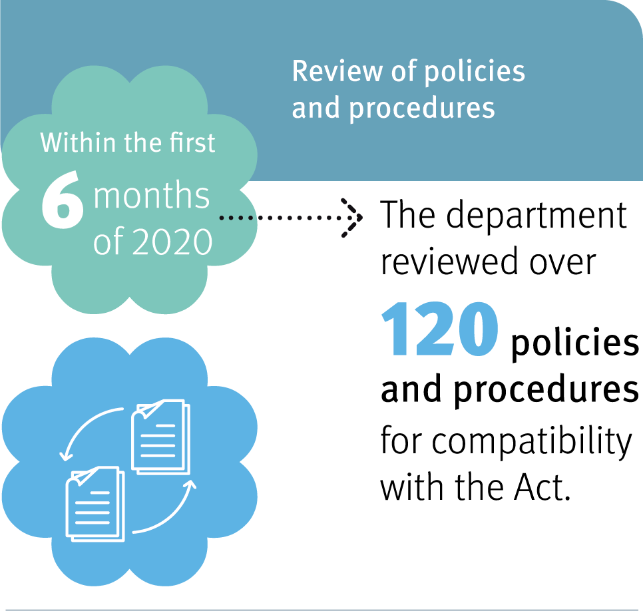

What we have done
Key achievements of this review process included:
- Reviewing draft guidelines, tools and resources, to support the department’s completion of internal reviews under the Child Protection Act 1999 from 1 July 2020, with no limitations on human rights identified.
- Assessing the department’s Student Learning and Wellbeing Framework. The Framework was assessed as compatible with the Act, positively engaging the right to protection of families and children (s26) and the right to education (s36). No limitations on human rights were identified.
- Assessing the department’s Inclusive Education Policy. The Policy was assessed as compatible with the Act, promoting the right to education and the right to recognition and equality before the law. No limitations on human rights were identified.
- Updating the Customer Complaints Management Framework, Policy and Procedure to incorporate the management of customer complaints with human rights components.
The department developed a Human Rights Impact Assessment Table. This tool is designed to assist policy and project officers to review existing policy, procedures, guidelines and decision- making frameworks for compatibility with the Act and to identify any changes that may be needed. Information and resources to assist the assessment are included within the tool.
The department is continuing to update briefing note templates, and departmental operational planning templates to include consideration of human rights impacts and compatibility, and to embed respect for human rights in organisational processes. Staff are now required to describe how human rights have been considered in relation to the issue or proposal, including whether any decision or action made will lawfully limit human rights. Consideration of child safe principles with a focus on supporting the rights of the child has also been included in Executive Management Board briefing note templates.
The department is developing targeted resources to assist staff in making employment decisions and to appropriately consider human rights in their acts or decisions including a flowchart, guide and record keeping tool. These resources will be made available on the department’s intranet when finalised. The department will continue to look for opportunities to develop targeted resources for staff.
Review of policies and procedures is an ongoing part of the department’s implementation process.

Case study –

Managing student health support needs at school
The department identified possible human rights limitations in two procedures involving health management for students, the:
- supporting students with asthma and/or at risk of anaphylaxis at school procedure; and
- managing students’ health support needs at school procedure.
The limitation in both procedures related to providing emergency lifesaving intervention when informed consent could not be obtained from a student or parent.
Following consideration of potential impacts, the limitation was considered to be justified as the principal has a duty of care in emergency and lifesaving situations. It was identified that the Managing students’ health support needs at school procedure required more explicit information included about gaining informed consent for the implementation of health procedures. The procedure updates were published in July 2020.

Case study –

School Disciplinary Absences
The decision to suspend or exclude a student from school is a complex activity that has always required principals to balance the rights of an individual student with the need of the school to provide a safe environment for all members of the school community.
The introduction of the Act emphasises the importance of considering the rights of the student, including appropriately documenting decisions, and, where a student’s rights are being limited, providing evidence that this action is lawful, justified and reasonable.
The ongoing revision of all student discipline procedures, including the introduction of decision-making flowcharts and checklists, is designed to help ensure that schools understand and meet their legislative obligations, assist decision-making and ensure documentation in line with these obligations.

Indicator 6

Implementation of internal complaint management for human rights complaints
- Has your agency incorporated human rights complaints into existing complaint processes?
- Does your agency’s complaints policy prompt staff to consider whether human rights of any individual have been engaged and limited?
- Have you implemented a process for identifying, assessing and considering, and responding to human rights complaints?
- Can you think of examples of when a complaint has been resolved through the internal complaints process and/or has resulted in policy/procedure/practice review or change for the agency?

Agency context
The department has a number of complaint processes across customer, staff, privacy, corrupt conduct and misconduct, international students and registered training providers with internal systems in place to capture, assess and manage these complaints. The department’s customer complaints and compliments webpage outlines how complaints are handled, assessed and resolved. The department has recently upgraded its Customer Complaints Management System (CCMS) to incorporate the management of human rights complaints. Human rights consideration is now embedded in the customer complaints assessment and resolution process.

What we have done
The department’s customer complaints management framework, policy and procedure have been updated, online training resources developed, and relevant enhancements to the CCMS have occurred. The public facing customer complaints and compliments webpage has been updated to include information about human rights. The customer complaints framework, which is aligned to the Australian/New Zealand Standard on complaints management, has been updated to provide staff with information and guidance when managing customer complaints that may engage human rights. Complaints officers must document their assessment and decision-making process for human rights complaints. Most customer complaints are managed and resolved through early resolution at the school, regional or divisional level. Where a customer remains dissatisfied a review process is instigated.

There is now targeted guidance for staff who manage customer complaints to consider whether a complaint may have engaged a human right. This includes providing advice to regional staff conducting virtual regional reference groups to work through relevant examples; providing resources and information to staff and the general public on our department website and intranet about the department’s approach to managing human rights complaints; and producing a targeted guide: Customer complaints management and human rights.

Case study –

Dress Code – Human Rights Complaint Process
The human rights complaint was managed through the department’s customer complaints management framework.
The region conducted an internal review of a school’s decision regarding uniform and dress code.
As an outcome of the internal review, the region and the school Principal reviewed current dress code arrangements and continued a dress code exemption for the student. School staff also continued to work with the student to provide a health plan to ensure appropriate supports are in place.

Case study –

Cultural Rights – Human Rights Complaint Process
The human rights complaint was managed through the department’s customer complaints management framework. The complaint was received at the region, which worked with the school to manage and resolve the matter. The complaint was regarding Aboriginal and Torres Strait Islander significant dates and events not being celebrated at a school.
As an outcome of the complaint, the school communicated with the complainant and provided information about the learning resources that were shared with all staff to augment and continue the discussions within classes for National Sorry Day and National Reconciliation Week.

Future plans
Supporting staff managing complaints to consider whether any human rights have been engaged and limited will remain a focus area for ongoing implementation of the Act, with additional guidance and information provided as needed. Future-focused implementation activities for the department will include development of additional training opportunities, and resources and tools to assist all departmental staff in considering human rights in their actions and decision-making.

Indicator 7

Future plans
- protecting and promoting human rights;
- building a culture in the Queensland public sector that respects and promotes human rights; and
- helping promote a dialogue about the nature, meaning, and scope of human rights.
The department has taken important steps toward meeting the objects of the Act during the first phase of implementation from mid-2019 to mid-2020. The department has extended and expanded its commitment to human rights with approval for project work to continue to coordinate and support ongoing work to build a human rights culture in the department.
A phased approach to implementation readiness was necessitated by the short implementation timeframe of 6 months, and agency context of a large, geographically dispersed operational workforce. Now the Act has commenced and must be considered in all departmental decisions and actions, a carefully considered and dedicated whole-of-department human rights framework and implementation plan is being developed to ensure ongoing strategic and coordinated oversight of the implementation of the Act across the department.
This next phase will focus on strengthening and sustaining organisational engagement and commitment to a human rights culture and embedding consideration of human rights in business-as- usual processes. Key priorities will be delivering a sustainable capability development program for all staff, ongoing stakeholder communication and engagement and ongoing reporting, monitoring and oversight arrangements of the department’s progress towards embedding a human rights culture.
Review of complaints data and outcomes, along with stakeholder feedback will inform future policy and system reviews and project actions.
The project will identify and consolidate efforts being undertaken across the department which promote and protect human rights and ensure these are captured by an overarching human rights framework.

Additional questions: COVID-19

Pandemic response and recovery impacts on implementation activities
The QHRC recognises that the COVID-19 pandemic has caused major disruption to the business of Queensland public sector entities.
At the same time, the COVID-19 pandemic has been a significant test of the Act, with agencies being required to consider and act compatibly with human rights and respond proportionately in the context of a major health emergency.
- To what extent has your agency’s COVID-19 pandemic response impacted on the implementation of the Act?
- Can you provide any examples of how your agency has properly considered and acted compatibly with human rights (as required by section 58 of the Act) when responding to issues arising during the COVID-19 pandemic emergency period?

Protecting the right to education during the COVID-19 pandemic
A key function of the department is to promote and protect the right to education in Queensland. This includes ensuring that:
- Every child has the right to have access to primary and secondary education appropriate to the child’s needs.
- Every person has the right to have access, based on the person’s abilities, to further vocational education and training that is equally accessible to all.
Given the right to education is an enabling and empowering right, the prospect of students losing access to education and disruptions to continuity of learning during the pandemic was identified as a key risk. From Term 2, 2020, schools and Queensland community kindergartens were to deliver learning from home for a period of 5 weeks, with a staged return of students.
The department ensured schools and Queensland community kindergartens remained open and accessible for children of essential workers and vulnerable children during the learning at home period. The department was also able to quickly mobilise significant resources to protect and promote students’ right to education. Open access to collaborative platforms for teaching and learning were rapidly deployed. The delivery of learning@home online and the development of programs in partnership with free to air commercial television helped support learning from home.
Schools and schooling sectors were also provided access to a range of collaboration and learning resources and applications. Enabling schools to use a number of resources and applications meant that the load was spread more effectively across the system and schools could choose the resource or application most suited to their school community.

The learning@home and Learning Place websites will continue to be available as the sector recovers from the disruption to education. Two-week units of work across the English, Mathematics and Science curriculum areas for Prep to Year 10 students are being progressively released during the remainder of 2020. Teacher resources aligned to the units of work have been made available to state schools through the department’s platform, the Learning Place.
Furthermore, in line with section 15 of the Act, every person has the right to enjoy their human rights without discrimination. Accordingly, the department built a collection of inclusive resources designed to provide targeted support for students with disability during the learning at home period. The resources assisted parents and supported students to engage in learning alongside their similar-aged peers, supported by reasonable adjustments tailored to meet their individual needs in the home environment. Assistive technologies to support all learners were also provided on the department’s learning@home web page to ensure inclusion of all children.
Boarding students and international students were supported by the department to continue to access learning within local communities, where possible.
With the shift to learning at home, gaps in student access to the technology became more evident. Schools moved to provide devices and/or internet access for those students who had no or limited access to online learning materials.
The department is reflecting on strategies used during the learning at home period and targeting activity for future recovery opportunities. Supporting staff and student IT capability and access to technology for schools and students will be a priority.
The experience has demonstrated a strong commitment from all staff and sector stakeholders to the importance of protecting and promoting the right to education and acting compatibly with human rights when responding to issues arising from the pandemic.

Further impacts
The OIR leadership was meeting weekly during the initial pandemic response and are continuing to meet fortnightly during the transition back to the workplace to monitor and respond to impacts both to staff and stakeholders during the pandemic. The priority focus has been on the safety of our people. OIR have also been actively involved in providing ongoing national and state advice in relation to industry and site COVID safe plans for businesses and assisting the Public Service Commission. The management of this new hazard has meant a reorganisation of operational priorities including the implementation of further initiatives and training for Human Rights. OIR continue to monitor the health and wellbeing of staff through internal pulse surveys “healthy@home”.
Until March 2020, the department delivered face-to-face training workshops designed to raise awareness of the Act for central and regional office staff. A program that was intended to be delivered to school principals was postponed because of the social distancing requirements and the need to redeploy staff on other duties. The capacity to create video training materials to replace or supplement face-to-face training during and immediately after the COVID-19 crisis was constrained by response priorities focused on supporting sector viability, continuity of learning and staff and student safety and wellbeing.
Learning from this disruption, our priorities now include the development of sustainable training and capability building opportunities that are readily accessible when needed.

© State of Queensland, Department of Education 2020
The Queensland Government supports and encourages the distribution of its material.
Unless otherwise noted, all copyright material available on this website is licensed
under the Creative Commons Attribution 4.0 International licence (CC BY 4.0).

Design reference: DoE 39932_05

