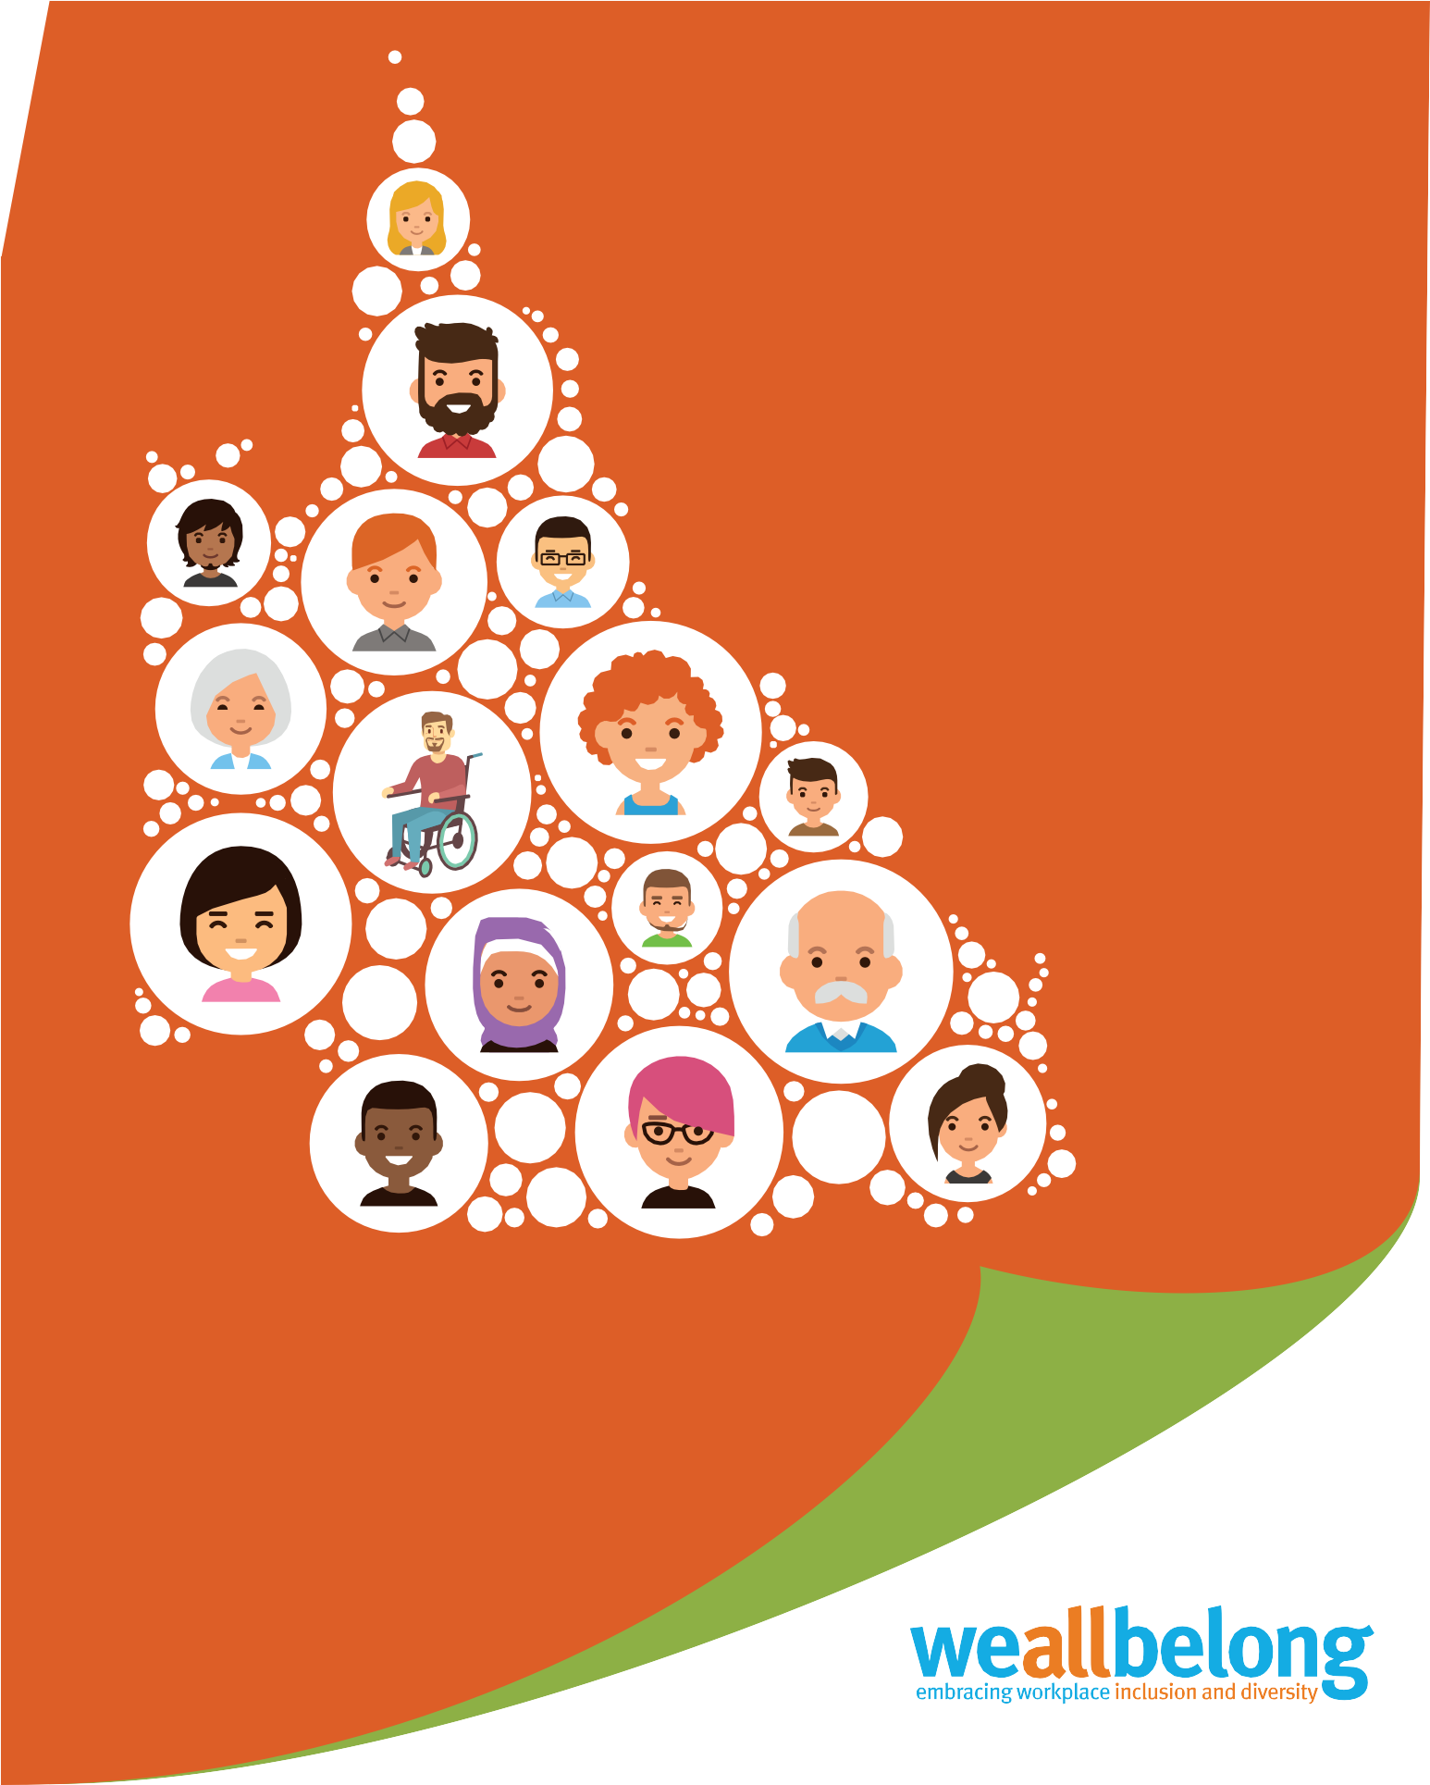

Workforce
Diversity Census

Part of the

initiative
WORKFORCE DIVERSITY CENSUS

Your diversity is our strength!

As an employee you bring diverse skills, knowledge and experience. You are part of a team that values diversity and is committed to maintaining an inclusive work environment where everyone feels that they belong.

Workforce Diversity Census (WDC) data is critical to understanding the diversity of everyone in our workforce and designing our Inclusion and Diversity programs of work to meet these needs.

We invite you to share information about your diversity, noting that all information is confidential and protected.
This is an opportunity for you to celebrate who you are, enabling us to value your diversity and uniqueness.

Employees wishing to update their WDC record can complete the paper-based census form at any time. Please return your completed WDC form to (no stamp is required):

“CONFIDENTIAL”
Human Resources – Workforce Reporting (Census)
Workforce Planning
Reply Paid 15033
CITY EAST QLD 4002

Privacy
This form has been issued by the Public Service Commission to assist in the collation of workforce diversity data between Queensland public sector agencies, consistent with the Public Service Act 2008. It includes minimum requirements.

You can be confident that your information will be used in accordance with the Information Privacy Act 2009, that your agency is bound by. The information you provide will be used for statistical purposes only and no information identifying you personally will be disclosed to any agency or person.

If you’re in an agency where you provide this information via a paper-based form, then authorised officers will have access to the information you provide for the purposes of data entry only. Your completed form will be confidentially destroyed once the data has been entered.

Your data, once on file, is only accessible by appropriately authorised officers within your agency and shared-service provider.

Section A – Employee details
Section A – Employee Details (minimum response required)
Section A – Employee Details (minimum response required)

This section captures minimum required employee information and allows confirmation that employees have been given the opportunity to complete this form. If employees do not complete this section, agencies will need to further request this information until provided by employees.
Section A – Employee Details (minimum response required)
Payroll number |  | School/ Work unit Agency
 |  |  |  |  |  |  |  | Department of Education
First name |  |  |  | Middle name |  | Last name
Section A – Employee Details (minimum response required)

Section B – Diversity - Please only select one response per question.
Gender identity

Question 1: Which of the following best describes your gender identity?
Gender and sex, although historically used interchangeably, are not the same. This question asks about your gender identity, which is a social and cultural concept. It is about social and cultural differences in identity, expression and experience as a man, woman or non-binary person. Non-binary is an umbrella term describing gender identities that are not exclusively man or woman.

Please select one box only.
Man
Woman
Non-binary
I do not wish to answer this question
*Note: for Queensland public sector workforce profile reporting purposes only, if an individual selects ‘I do not wish to answer this question’, for Question 1, gender will default to the sex identified on the individual’s commencement/new starter form.
Aboriginal peoples and Torres Strait Islander peoples

Question 2: Are you an Aboriginal person or Torres Strait Islander person?
An Aboriginal or Torres Strait Islander person is a person of Aboriginal or Torres Strait Islander descent and who identifies as such and is accepted as such by the Aboriginal or Torres Strait Islander people in the community in which they live, or have lived.
Aboriginal peoples and Torres Strait Islander peoples are the First Peoples of Australia.
Are you an Aboriginal person or Torres Strait Islander person?
Please select one box only.
Yes, I am an Aboriginal person
Yes, I am a Torres Strait Islander person
Yes, I am both an Aboriginal and Torres Strait Islander person
No, I am not an Aboriginal person or a Torres Strait Islander person
I do not wish to answer this question
*Note: an employee may identify as an Aboriginal person, Torres Strait Islander person and an Australian South Sea Islander person through their answers to Question 2 and Question 3.

Australian South Sea Islander peoples

Question 3: Are you an Australian South Sea Islander person?
Australian South Sea Islander people are the direct descendants of South Sea Islanders brought to Australia between 1863 and 1904 to work as indentured labourers.
Please select one box only.
Yes, I am an Australian South Sea Islander person
No, I am not an Australian South Sea Islander person
I do not wish to answer this question

People with disability

Question 4: Do you have a disability?
A person has disability if they have a limitation, restriction or impairment which has lasted, or is likely to last, for at least six months and may restrict everyday activities. There are different kinds of disability, usually resulting from accidents, illness, or genetic disorders, and may include:
- physical – affects a person’s mobility, dexterity, stamina/fatigue, speech
- sensory – affects a person’s ability to hear, see, touch, smell or concentrate
- intellectual – affects a person’s abilities to learn
- mental illness – affects a person’s thinking processes, including post traumatic stress disorder (PTSD), anxiety disorders, depression
- neurological – affects the person’s brain and central nervous system and/or autonomic nervous system (e.g. stroke, acquired brain injury).
Other:
- receiving treatment or medication for any other long-term conditions or ailments but still may be restricted in everyday activities
- any other long-term conditions resulting in a restriction in everyday activities.
Based on the definition above, do you live with disability?
Please select one box only.
Yes
No
I do not wish to answer this question

Culturally and linguistically diverse people

Culturally and linguistically diverse (CALD) people are defined as any person who identify as all, or any of the following:
- born overseas, including English-speaking countries
- identify with a cultural background other than Australian – including identifying with more than one culture e.g., Chinese-Australian
- speak a language at home besides English (includes Aboriginal, Torres Strait Islander or Australian South Sea Islander languages).
Question 5: In which country were you born?
Please select one box only.
Born in Australia
Born overseas in a mainly English-speaking country, including but not limited to: New Zealand, United Kingdom, Ireland, Canada, United States of America and South Africa
Born overseas in a mainly non-English speaking country
I do not wish to answer this question
Question 6: Do you speak a language other than English at home?
This includes Aboriginal, Torres Strait Islander or Australian South Sea Islander languages.
Please select one box only.
Yes, I speak a language other than English at home
No
I do not wish to answer this question

